Class: COMP 3090 - Database I

Name: DangNhi Ngoc Ngo

Email: DangNhi_Ngo@student.uml.edu

Student ID: 01553277

**HOMEWORK #6**

**Exercise 6.5.1:**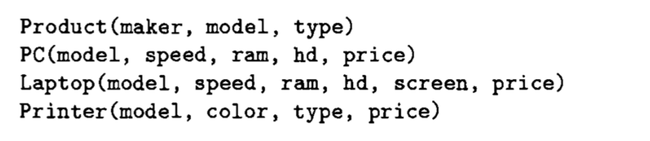

1. **Using two INSERT statements, store in the database the fact that PC model 1100 is made by manufacturer C, has speed 3.2, RAM 1024, hard disk 180, and sells for $2499.**

INSERT INTO Product

VALUES (‘C’, ‘1100’,’pc’);

INSERT INTO PC

VALUES (‘1100’, 3.2, 1024, 180, 2499);

1. **Insert the facts that for every PC there is a laptop with the same manufacturer, speed, RAM, and hard disk, a 17-inch screen, a model number 1100 greater, and a price $500 more.**

INSERT INTO Product (maker, model, type)

(SELECT maker, model+1100, ‘laptop’

FROM Product

WHERE type = ’pc’);

INSERT INTO Laptop (model, speed, ram, hd, screen, price)

(SELECT model+1100, speed, ram, hd, 17, price+500

FROM PC);

1. **Delete all PC’s with less than 100 gigabytes of hard disk.**

DELETE FROM PC

WHERE hd < 100;

1. **Delete all laptops made by a manufacturer that doesn’t make printers.**

DELETE FROM Laptop

WHERE model IN (SELECT model FROM Product WHERE maker IN (SELECT DISTINCT maker FROM Product WHERE maker NOT IN (SELECT maker FROM Product WHERE type =’printer’)));

1. **Manufacturer A buys manufacturer B. Change all products made by B so they are now made by A.**

UPDATE Product

SET maker =’A’

WHERE maker = ‘B’;

1. **For each PC, double the amount of RAM and add 60 gigabytes to the amount of hard disk. (Remember that several attributes can be changed by one UPDATE statement.)**

UPDATE PC

SET ram = ram * 2, hd = hd + 60;

1. **For each laptop made by manufacturer B, add one inch to the screen size and subtract $100 from the price.**

UPDATE Laptop

SET screen = screen + 1, price = price – 100

WHERE model IN (SELECT model FROM Product WHERE maker = ‘B’);